# **Integration of Postman with Jenkins**

***Last Updated On***

[**September 29, 2023**](https://qaautomation.expert/2023/09/08/integration-of-postman-with-jenkins/)

[**HOME**](https://qaautomation.expert/)

Postman contains a full-featured testing sandbox that enables you to write and execute JavaScript-based tests for your API. You can then integrate Postman with your CI/CD build system using [***Newman***](https://learning.postman.com/docs/collections/using-newman-cli/command-line-integration-with-newman/), the command-line collection runner for Postman. In this tutorial, we are going to learn how we can integrate ***Postman with Jenkins***.

***Table of Contents***

1. [***Prerequisite***](https://qaautomation.expert/2023/09/08/integration-of-jmeter-with-jenkins-2/#why-do-we-need-to-integrate-jmeter-with-jenkins)
2. [***Implementation Steps***](https://qaautomation.expert/2023/09/08/integration-of-jmeter-with-jenkins-2/#implementation-steps)
3. [***Download the NodeJS Plugin***](https://qaautomation.expert/2023/09/08/integration-of-jmeter-with-jenkins-2/#download-performance-plugin)
4. [***Global Tool Configuration for NodeJS***](https://qaautomation.expert/2023/09/08/integration-of-jmeter-with-jenkins-2/#step-2-global-tool-configuration-for-nodejs)
5. [***Create a new FreeStyle project***](https://qaautomation.expert/2023/09/08/integration-of-jmeter-with-jenkins-2/#step-1-create-a-new-freestyle-project)
6. [***Source Code Management***](https://qaautomation.expert/2023/09/08/integration-of-jmeter-with-jenkins-2/#step-2-source-code-management)
7. [***Build Environment***](https://qaautomation.expert/2023/09/08/integration-of-jmeter-with-jenkins-2/#step-5-build-environment)
8. [***Select Execute Windows batch command***](https://qaautomation.expert/2023/09/08/integration-of-jmeter-with-jenkins-2/#step-3-select-execute-windows-batch-command)
9. [***Execute the tests***](https://qaautomation.expert/2023/09/08/integration-of-jmeter-with-jenkins-2/#step-5-execute-the-tests)

### ***Prerequisite:***

* Jenkins installed on the machine
* NodeJS installed on the machine

### ***Implementation Steps***

#### ***Step 1: Download the NodeJS Plugin***

To generate a Performance Report in Jenkins, we need to download ***NodeJS Plugin***. Please refer to this tutorial to install the plugin – [***How to install Plugins in Jenkins***](https://qaautomation.expert/2022/12/12/how-to-install-plugins-in-jenkins/).

Go to **Manage Jenkins > Manage Plugins** and install the NodeJS plugin.

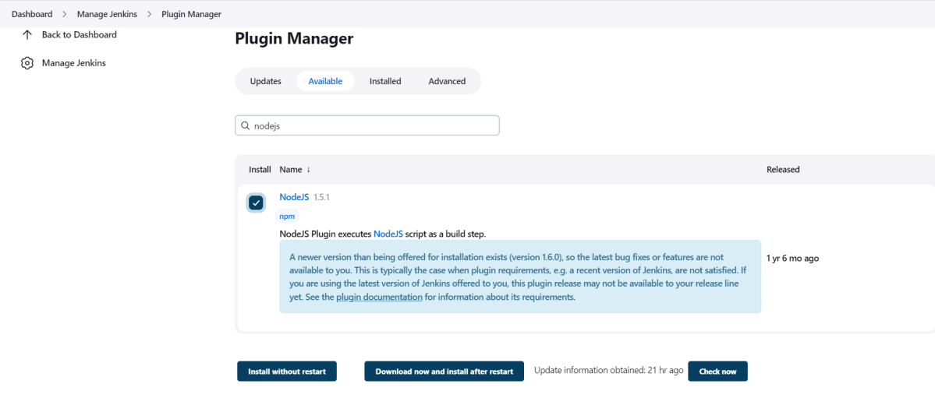

#### ***Step 2: Global Tool Configuration for NodeJS***

Go to ***Manage Jenkins > Global Tool Configuration****and under****NodeJS****, select****Add NodeJS***.

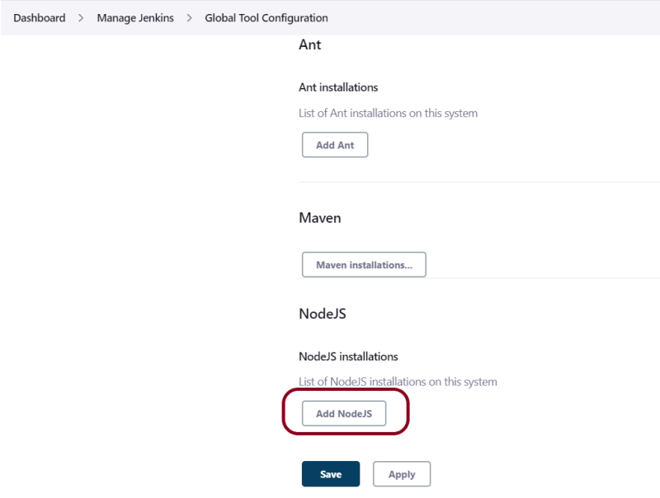

Advertisement

Enter a name for the Node.js installation.

Select the version of NodeJS installed on your machine from the Version dropbox.

In ***Global npm packages to install***, enter ***newman***.

Click on the ***Apply***and ***Save***buttons.

#### ***Step 3: Create a new FreeStyle project***

1. *Give the****Name****of the project* – ***Postman_Demo***
2. *Click on the****FreeStyle project.***
3. *Click on the****OK****button.*

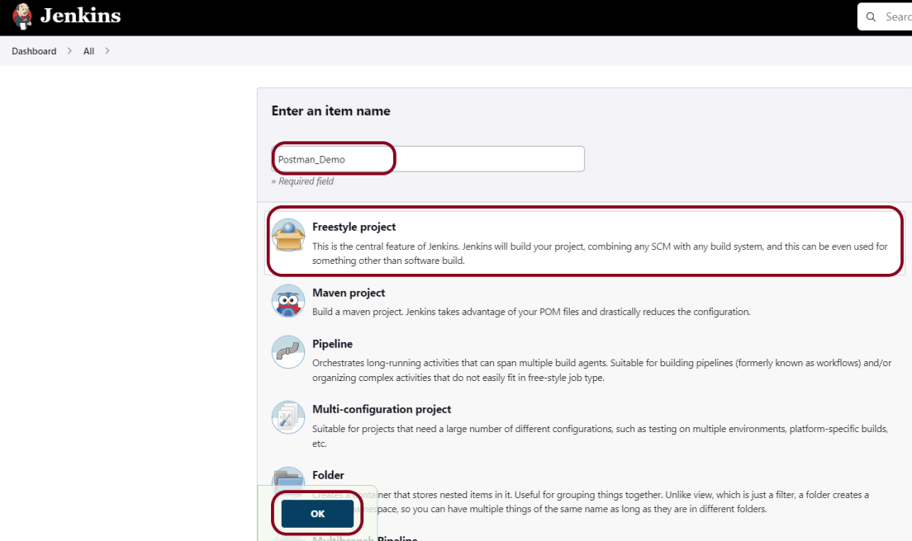

In the General section, enter the project ***description***in the Description box.

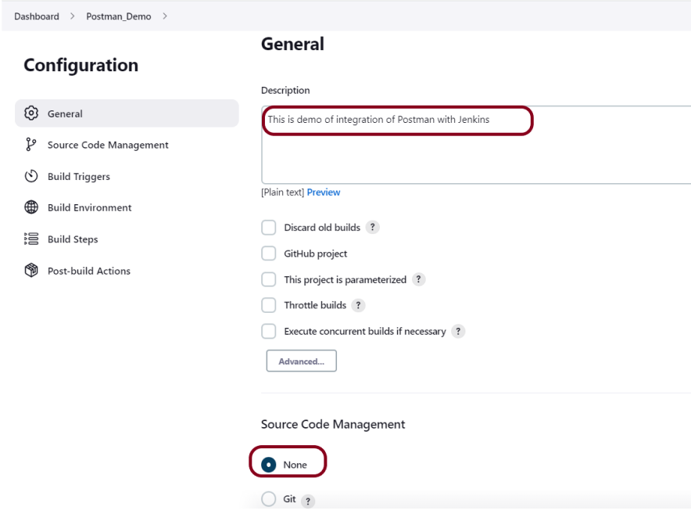

#### ***Step 4: Source Code Management***

Select ***Source Code Management as None***if the project is locally present on the machine.

#### ***Step 5: Build Environment***

Select the ***“Provide Node & npm bin/folder to PATH”*** option.

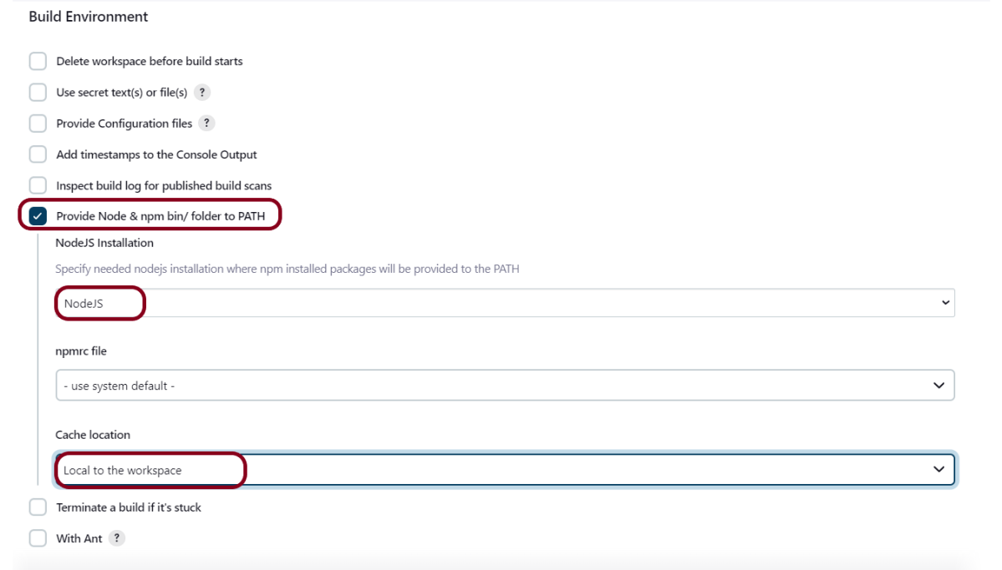

#### ***Step 6: Select Execute Windows batch command***

In the Build Steps section, select ***Execute Windows batch command***.

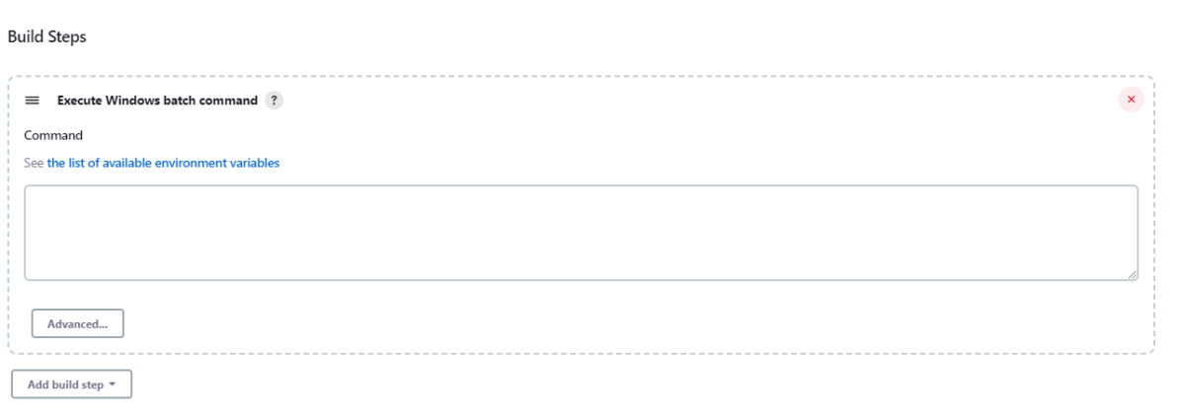

Use the below command to go to the path where the JMeter is placed in your system.

|  |  |
| --- | --- |
| 1  2 | cd C:\Users\Vibha\Desktop\Postman  newman run --disable-unicode API_Tests.json |

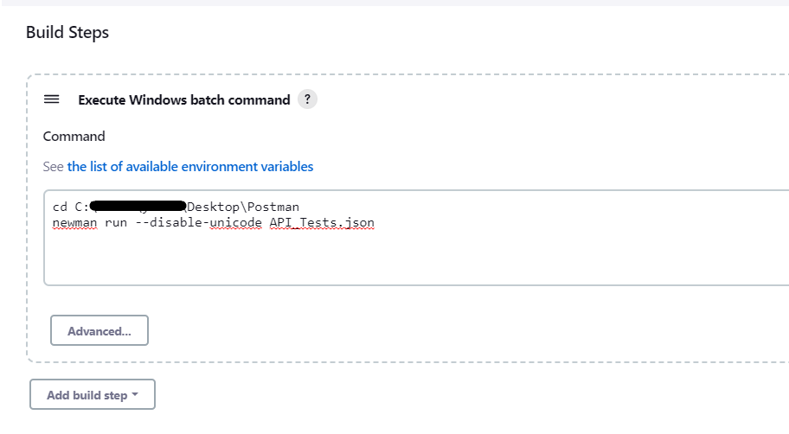

Click on the ***Apply***and ***Save***buttons.

We have created a new project **“*Postman_Demo***” with the configuration to run the Postman scripts.

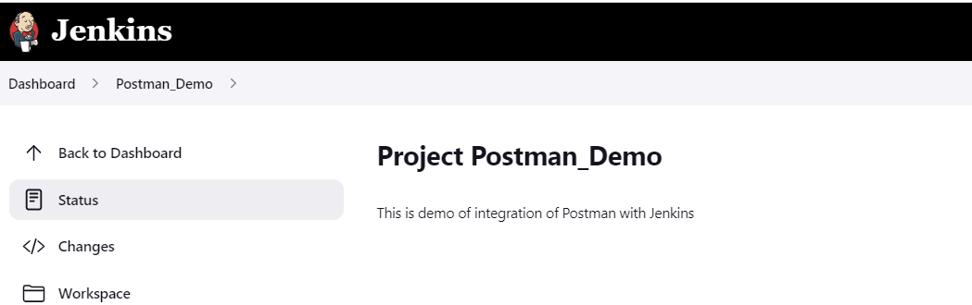

#### ***Step 7: Execute the tests***

Let’s execute it now by clicking on the “***Build Now***” button.

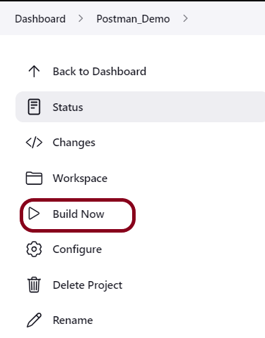

***Right-click*** on Build Number (here in my case it is #1).

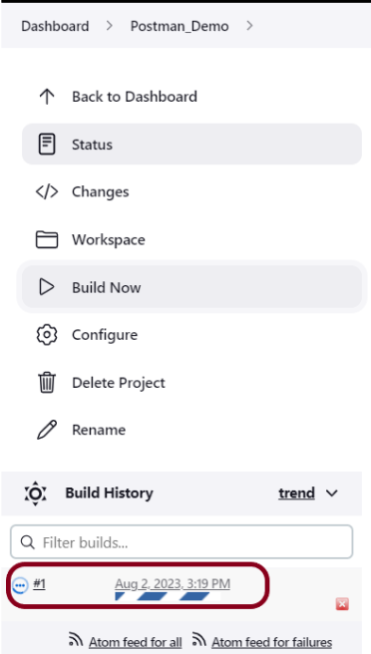

Click on ***Console Output*** to see the result.

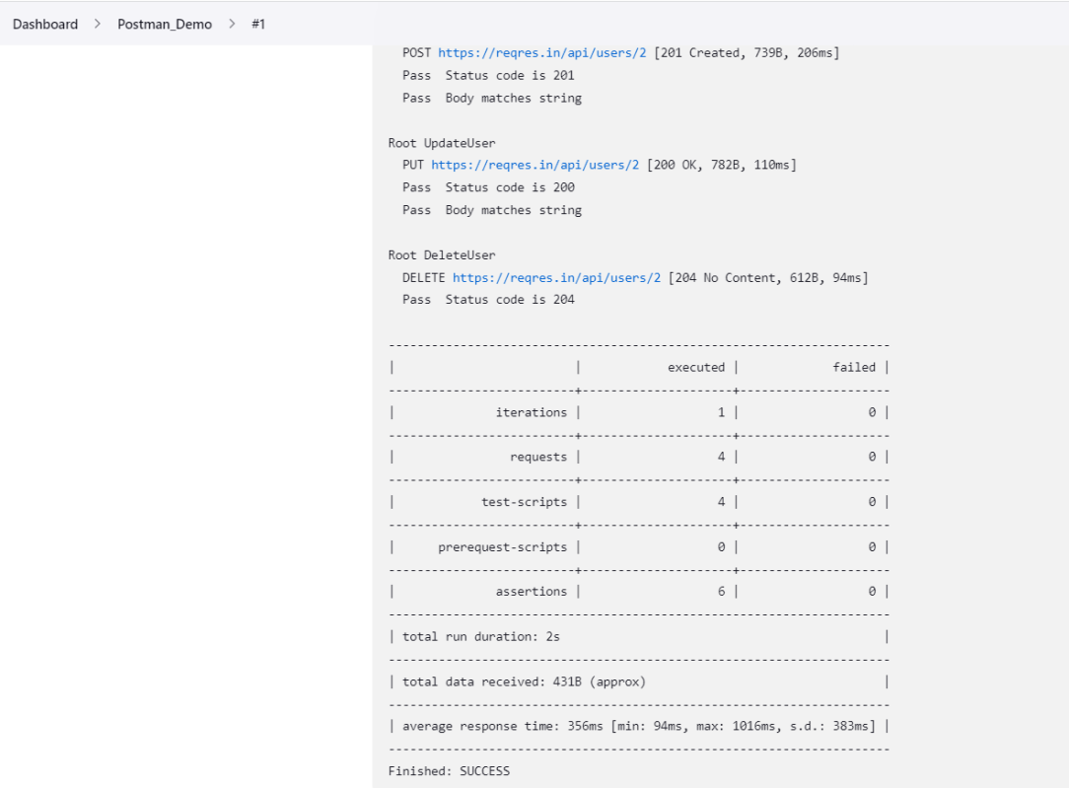

Congratulations on making it through this tutorial and hope you found it useful! Happy Learning!! Cheers!!